FEATURED

Galion woman publishes pet cookbook
Dillon Carr, Staff Reporter
Jul 11, 2016

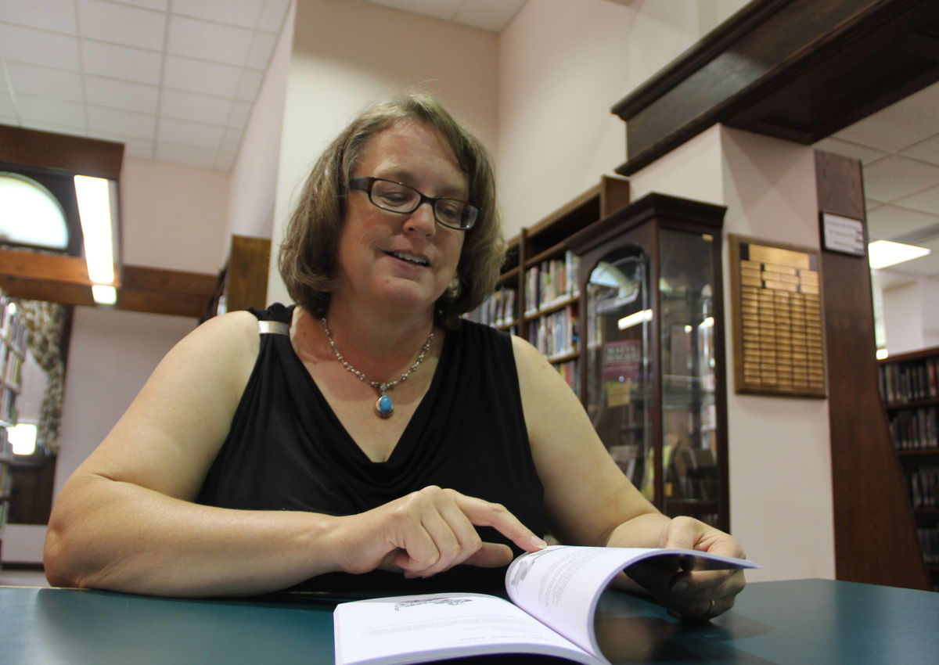
Noel Lizotte, author of "Good Dog! Pet Cookbook" leafs through recipes for dog treats.
GALION — As a single mom raising two teens while studying for a business degree, Noel Lizotte found little time to cook anything more than frozen or delivered pizza most nights.
She knew something had to change with her diet.
Once life settled, Lizotte decided to explore a more well-rounded diet for her and the family. Most of the exploration found itself on her blog, ApronFreeCooking.com. That was five years ago.
Today, she writes reviews of different recipes, creates her own, offers kitchen tips and writes various cooking books. Her latest, however, “Good Dog! Pet Cookbook” — well, it speaks for itself.
“There’s about 100 recipes in there,” Lizotte said. The recipes are all for dog treats, peppered with ingredients easily found at local grocery stores. The treats range in size to cater to the smallest to the largest breeds.
Lizotte said one of the fan-favorites from the book is the “Peanut Butter Oat Yummies.” The recipe takes about 20 minutes to prepare and bake. It calls for wheat flour, quick oats, peanut butter, wheat germ, baking powder, water and carob chips.
The recipe also includes a warning: stay away from Xylitol, a crystalline alcohol used as an artificial sweetener. The chemical is toxic to dogs.
“Even in small doses, it (xylitol) is fatal to dogs,” Lizotte said. But she doesn’t stop there with the advisories.
In the book, as part of its introduction, Lizotte provides a list of toxic foods for dogs. She said she wants her readers to gain knowledge about the different human foods that are toxic for dogs.
“These are all made with human made ingredients. You can buy them at Geyer’s or Kroger, or wherever you shop. You know what’s going into it so you know they’re not getting crazy chemicals or items that you wouldn't want to feed your dog,” she said.
Pet foods and treats are not currently required to gain FDA approval before heading out into the market. However, the FDA monitors whether ingredients are safe and accurately labeled. Lizotte said she is familiar with articles that claim pet food is unsafe for pets. Or the articles that claim that organic pet food is better.
“But some of them (articles) are pretty alarmist,” she said. “I don't try to debate one side of that argument or the other. I know what works for my dogs. I know what works for my family,” she said.
Mostly, the cookbook was inspired out of Lizotte’s love for cooking and her two dogs: Josie and Ranger. And her affection for her dogs only grows when she takes the time to cook or bake treats for them.
“When it’s your pet and you're spending a lot of time and you're focused on taking care of their dietary or nutritional needs, you’re baking treats for them — they become much more part of your family than just an animal that’s living in the same house,” Lizotte said.
“This isn’t the kind of book for someone who doesn't like to cook in the first place. Who bought an animal for their kids to play with and the dog is spending his time tied on a chain out in the backyard. This isn’t their book. This is definitely geared towards people who are much more involved in their dog’s daily routine.”
“Good Dog! Pet Cookbook,” self-published on May 10, is available to purchase for $8.95 on her website,Amazon or her Etsy page.
Originally published on www.RichlandSource.com on July 11, 2016

