POSTED ON JULY 27, 2016 BY GALION INQUIRER

Dog’s allergies lead to cookbook for pets
NEWS

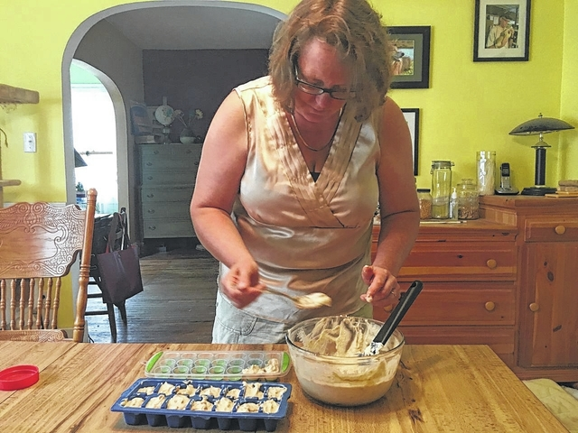
GALION — Noel Lizotte had already penned two cookbooks when her two dogs began struggling with food allergies. This prompted a third cookbook from the Galion-based author: “The Good Dog! Pet Cookbook.”
“We began experimenting with different foods for them,” said Noel of her two dogs, Josie and Ranger. “Josie was itching and having problems. Ranger came to live with us in November. Our other dog, Muffin, had to be put down in October.”
Ranger has herniated discs in his back after a fall that caused a broken back. He uses a wheelchair and requires daily, intensive therapy. The couple facilitated Ranger’s move from his former home in Texas to their Fairview Avenue home so Noel’s husband and wildlife rescue worker, John, could provide him with the treatment and attention he needs.
Noel said she tried organic and gluten free dog foods, but Ranger and Josie continued to have issues.
“They are both border collies, and are very intelligent. We have to interact with them a lot to keep them out of trouble, which means they get a lot of treat rewards. We’re using bacon strips,” Noel said. “With Ranger’s therapy alone, there are a lot of treat rewards.”
Noel started to research how dog food is manufactured.
“There is formaldehyde in a lot of dog foods. A small amount is not awful, but if your dogs are eating a lot of it, then there is a larger amount they are ingesting,” Noel said.
Noel began to experiment, using regular ingredients from the grocery or dollar stores to create a variety of treats for her dogs that would not cause allergic reactions.
“The dogs absolutely love the treats I make for them, and I thought if our dogs love them, so will other peoples’ dogs. That’s why I wanted to share my recipes with others,” Noel said.
Noel already had two published books under her belt, “Apron-Free Cooking,” and “30 Freezer Meals for Your Slow Cooker,” when she set about penning her pet cookbook.
“The Good Dog! Pet Cookbook,” has over 100 pages of recipes featuring all kinds of treats: frozen, baked, diabetic and vegetarian. The book even contains recipes for dog shampoos and anti-itch spray.
“Too many treats are being recalled as dangerous. We wanted to give our dogs treats they love and that we trust,” said Noel. “In the front of the book I even included a list of ingredients that are harmful to dogs. Most people know that chocolate is not good for dogs but there are several other foods they need to stay away from. For instance, some peanut butter contains Xylitol, which is very dangerous for dogs. I purchase the store brand at Save-A-Lot because it does not contain this ingredient.”
More information about the book is available on Noel’s Apron Free Cooking blog at http://www.apronfreecooking.com/good-dog-pet-cookbook. The book can also be purchased at Amazon.com.

